

DURHAM KENNEL CLUB
7318 GUESS ROAD, HILLSBOROUGH, NC 27278

AKC SANCTIONED B MATCH
Event No. 2026016146

August 8, 2026

INDOORS, CLIMATE CONTROLLED, FULLY MATTED
Entries: Pre-entry $5; Day of Match $10
No charge for Junior Showmanship

ONLINE ENTRIES: durhamkennelclub.com/Events/Conformation Matches

Day of Match entries 10 am to 11 am Judging begins at 11:30 am

Puppy 3-6, 6-9, 9-12
Bred by Exhibitor ~ Open ~ Junior Showmanship

Adults and Puppies judged separately
Classes Divided by Sex - Judged Alphabetically in Group

Dogs with Majors may compete Awards for BEST PUPPY IN MATCH BEST ADULT IN MATCH BEST JUNIOR HANDLER IN MATCH

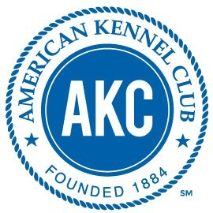
AMERICAN KENNEL CLUB CERTIFICATION
Permission has been given by the American Kennel Club for the holding of this event under American Kennel Club rules and regula- 1 ons.
Shelia Goffe, Execu ve Secretary

AKC Code of Sportsmanship

PREFACE: The sport of purebred dog compe ve events dates prior to 1884, the year of AKC’s birth. Shared values of those involved in the sport include principles of sportsmanship. They are prac ced in all sectors of our sport: conforma on, performance and companion. Many believe that these principles of sportsmanship are the prime reason why our sport has thrived for over one hundred years. With the belief that it is useful to periodically ar culate the fundamentals of our sport, this code is presented.

· Sportsmen respect the history, tradi ons and integrity of the sport of purebred dogs.
· Sportsmen commit themselves to values of fair play, honesty, courtesy, and vigorous compe on, as well as winning and losing with grace.
· Sportsmen refuse to compromise their commitment and obliga on to the sport of purebred dogs by injec ng personal advantage or considera on into their decisions or behavior.
· The sportsman judge judges only on the merits of the dogs and considers no other factors.
· The sportsman judge or exhibitor accepts construc ve cri cism.
· The sportsman exhibitor declines to enter or exhibit under a judge where it might reasonably appear that the judge’s placements could be based on something other than the merits of the dogs.
· The sportsman exhibitor refuses to compromise the impar ality of a judge
· The sportsman respects the AKC bylaws, rules, regula ons and policies governing the sport of purebred dogs.
· Sportsmen find that vigorous compe on and civility are not inconsistent and are able to appreciate the merit of their compe on and the effort of compe tors.
· Sportsmen welcome, encourage and support newcomers to the sport.
· Sportsmen will deal fairly with all those who trade with them.
· Sportsmen are willing to share honest and open appraisals of both the strengths and weaknesses of their breeding stock.
· Sportsmen spurn any opportunity to take personal advantage of posi ons offered or bestowed upon them.
· Sportsmen always consider as paramount the welfare of their dog.
· Sportsmen refuse to embarrass the sport, the American Kennel Club, or themselves while taking part in the sport.
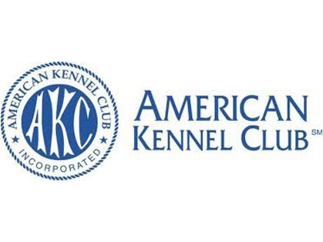

2


AKC Sanctioned B Match Event No. 2026016146
August 8, 2026

Mail Pre-entries (Checks payable to DKC)

Durham Kennel Club
9514 Bridle Spur, Chapel Hill, NC 27516-5755 online entries: durhamkennelclub.com ~ Events/Conformation Matches
No confirmation of entry will be sent

Pre-entries $5 —- Day of Match Entries $10
Dog’s Name | (Call name okay)
 | Breed
 | Sex Date of Birth
Owners Name
email
Puppy 3 -6 months |  | Bred By Exhibitor
Puppy 6-9 months |  | Open
Puppy 9-12 months
Junior Showmanship—Novice
Junior Showmanship—Open
/

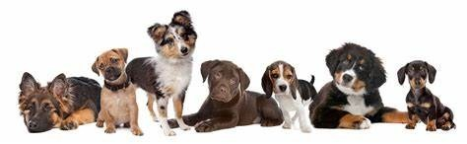
Match Chair: Linda Wozniak ~ Match Secretary: Jill Elefante

For More Information: lcwshows@att.net or 919.302.4569 3

